Product Requirements Document

Haptic Wearable for Education

# Metadata

## Team

|  |  |  |
| --- | --- | --- |
| **Member** | **Role** | **EMail** |
| Daniel Shor | Lead Engineer | Contaxtuallabs at gmail dot com |
|  |  |  |

## Milestones

|  |  |
| --- | --- |
| Design Freeze | Date |
| End of Prototyping Phase | Date |
| End Engineering Validation Testing |  |
| End Design Validation Testing Phase |  |
| End Production Validation Testing Phase |  |
| Mass Production Start |  |
| Global Availability |  |
| Product Launch |  |

# Overview

## Introduction

This wearable is a platform for education in haptics and human computer interaction (HCI). This wristband haptic wearable contains a voice coil actuator that provides feedback through vibrations, felt on the user's skin. This product enables students and novice hapticians to quickly begin prototyping with advanced haptic feedback waveforms. This device offers a low cost way to mimic wearables such as a SmartWatch without the full need for complex hardware. For example, it can vibrate with a steady pulse to indicate an incoming call or message, or it could vibrate in a more complex pattern to convey the direction of a turn while navigating. Users can connect to this device using Bluetooth, and send audio signals directly to the device.

## Product Image

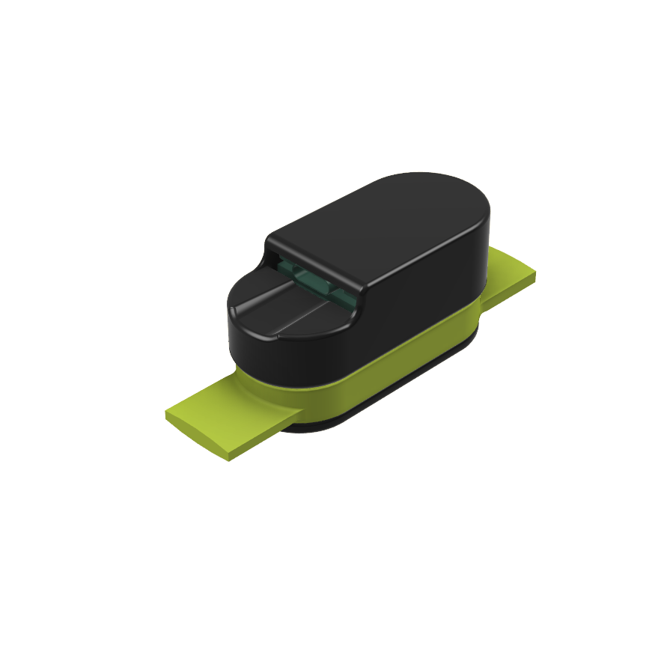

## Product Description

|  |  |
| --- | --- |
| Market Need | Haptics have a growing demand in HCI design, however, there are few good toolkits for haptic prototyping. The goal of this project is to produce a simple haptic “smart speaker” to allow the rapid testing and development of wristband wideband haptics. |
| Key Features/ Functionality | * Bluetooth connection * Audio to Haptics DSP * Wideband Haptics from 40-500 Hz |
| Other Product Compatibility,  Ecosystem, etc. |  |

## Stakeholders

|  |  |
| --- | --- |
| Target User | Who will use your product? |
| Target Purchaser  (if different from user) | Who will buy your product? |
| Other Stakeholders | Who else should be considered? |

# Commercial and Regulatory

## Sale Info

|  |  |
| --- | --- |
| Countries of Sale | In which countries will you sell this version of the product? |
| Target Launch Date | July 01 2023 |

## Financials

|  |  |
| --- | --- |
| BOM Cost | 35 Euro |
| COGs | 40 Euro |

## Volume

|  |  |
| --- | --- |
| MOQ of First Production Run | 20 |
| Annual Volume | 100 |
| Timeline for Product Refresh (EOL) | 3 Years |

## Regulatory Requirements

|  |  |
| --- | --- |
| Safety (UL, CE) | Prototype Hardware: None |
| Emissions (FCC, CE) | Prototype Hardware: None |
| Interoperability (Cellular, WiFi) | Bluetooth 4.0+  The firmware is compiled on the ESP-IDF platform. |

## Labeling

|  |  |
| --- | --- |
| Regulatory Marks | * Prototype Hardware: None |
| Country of Origin | * Local manufacturing, no country of origin |
| Serial Number | * Revision Numbers   + Inside Casing |
| Other Markings | * Assembly indicators   + Orientation Indications – front, etc.   + Component Naming/Markings |

# Environmental

## Environment

|  |  |
| --- | --- |
| Use Enviroment | The wrist worn wearable electronic device must be designed to function in a variety of product use environments. It should be capable of withstanding exposure to common environmental factors such as temperature, humidity, dust.  The device should be able to withstand human skin contact, including light amounts of sweat. The device should be worn indoors only, and in a classroom setting. The device should not be exposed to any significant moisture or dust/grime. The device should not be used outdoors. |
| Storage Temperature & Humidity Range | The device should be designed and tested to operate within a temperature range of 0°C to 35°C (32°F to 95°F) and a relative humidity range of 30% to 80%. These ranges have been established to ensure that the device can function properly without being damaged or degraded in any way. |
| Operational Temperature & Humidity Range | The device should be designed and tested be stored within a temperature range of 0°C to 35°C (32°F to 95°F) and a relative humidity range of 30% to 80%. These ranges have been established to ensure that the device can function properly without being damaged or degraded in any way.  If the temperature or humidity exceeds these ranges, it can cause damage to the device's internal components, affect battery life, or lead to malfunction. |

# Industrial Design

## Renderings

## Identity

|  |  |
| --- | --- |
| Brand | What should your product communicate about your company values? |
| Color, Material, and Finish (CMF) | Which colors and textures will be used? |
| Logo size and placement | Where will the logo be placed? |

## Interfaces

|  |  |
| --- | --- |
| Connectors  (Power, USB, Lighting, Audio) | * Power   + USB Micro or USB-C |
| Visual Interface  (Screen size and type, LEDs) | * Power On/Off   Power will be communicated by the appearance of a light in the casing. If there is no power, the device with display no light. If there is power, the device will illuminate with a RGB LED. The LED color will vary depending on the Bluetooth connectivity status.   * Bluetooth Status   + Connected   When Bluetooth is connected, the device will illuminate the RGB LED in GREEN   * + Not Connected   When Bluetooth is not connected, the device will illuminated the RGB LED in RED   * + Pairing Mode   When the Bluetooth device is in pairing mode, the RGB LED will blink slowly – approx. 10 blinks/second. |
| Touch Interface  (Mechanical actuators/switches, touch sensitivity, haptics) | How will people interact with their sense of touch? |
| Audio Interface  (Microphones, speakers) | Which audio inputs and outputs? |

# Software Architecture And Data Processing

## Block Diagram of Data Flow

# Electrical Hardware And Sensors

## Block Diagram of Electrical Hardware

## Electrical Requirements

|  |  |
| --- | --- |
| Input/Sensor Requirements | What should be sensed and to what accuracy? |
| Output/Actuator Requirements | How does the product affect its physical world? |
| Communication Requirements | Uses the A2DP protocol to transmit audio dat（call reception is not supported). After power on, the red LED is displayed. When the connection with a Bluetooth device is established, the LED turns green and sounds can be output. The LED turns red when the device disconnects. |
| Power Requirements | Should it be plugged into an outlet or powered with disposable or rechargeable batteries? If batteries, how long should it last between replacement or recharging? |

## Critical BOM Items

|  |  |  |  |
| --- | --- | --- | --- |
| Item Name | Internal S/N | Link to Source | Link to Datasheet |
|  |  |  |  |
|  |  |  |  |
|  |  |  |  |
|  |  |  |  |
|  |  |  |  |
|  |  |  |  |
|  |  |  |  |
|  |  |  |  |

# Mechanical Hardware & Materials

## Critical BOM Items

|  |  |  |  |  |
| --- | --- | --- | --- | --- |
| Item | Type: | Used In: | Supplier | Link |
|  |  |  |  |  |
|  |  |  |  |  |
|  |  |  |  |  |
|  |  |  |  |  |
|  |  |  |  |  |
|  |  |  |  |  |
|  |  |  |  |  |
|  |  |  |  |  |

## Manufacturing

|  |  |
| --- | --- |
| Manufacturing Processes | * Plastics   + Plastics must be 3D printable (FDM/SLA)   + Plastics should be FDM compatible. |
| Manufacturing Tools | * Prusa Ecosystem 3D Printers   + Prusa mk3s Printer   + PrusaSlicer   + Prusa Filament |
|  |  |

## Materials

|  |  |  |  |  |
| --- | --- | --- | --- | --- |
| Material | Type: | Used In: | Supplier | Link to MSDS |
| PLA | Filament | Casing | Prusament |  |

## Circularity & Recyclability

|  |  |
| --- | --- |
| Raw Materials | * Plastics   + Plastics |

# Durability

|  |  |
| --- | --- |
| Lifetime requirements | How long should the product last before it is unusable? |
| Cycles of various sub-systems | How long should specific parts of the product last? |
| Chemical resistance (sweat, sebum, sunscreen, salt water) | Which chemicals should the product resist? |
| UV resistance (sunlight) | Should be product be UV resistant? |
| Environmental (Dust, Water, etc.) | Dust or water? Use IPX codes here. |
| Mechanical (Drop, Vibration, Abrasion, etc.) | What mechanical abuse should the product withstand? |